WORKSHEET

EDSCLS School Climate Data Analysis

Introduction
Congratulations! Now that you have collected your U.S. Department of Education (ED) School Climate Surveys (EDSCLS) data, you can dig in to see what your data are telling you. For each respondent group that you surveyed (students, instructional staff, noninstructional staff, and parents), you can produce EDSCLS reports that show how respondents perceive various aspects of the climate in your state, district, or school.
This worksheet provides key questions to help you make sense of your EDSCLS survey results. To help you answer those questions, this worksheet also provides information on what EDSCLS reports to run to find information and displays, explains relevant screenshots, and provides space after each question for you to write down what you found. From there, you can take what you learned to share with your stakeholders.
The first two questions refer to benchmarked scale score data. Beginning with the release of the EDSCLS platform VM 3.0 in December 2017, the way the platform transforms scale scores into whole numbers was changed to create three school climate levels: Least Favorable, Favorable, and Most Favorable for all scales. Using these levels, users can compare respondents’ perception of school climate across topics, domains, or respondent groups (e.g., if a school is in performance level 1 [Least Favorable] for engagement and performance level 2 [Favorable] for safety based on the student survey results, it suggests that students in the school feel the school is not doing as well in engaging students as it is in providing safety to students. However, the questions below are organized only around topic areas within domains for ease of presentation and to aid thinking through the large amount of data that the EDSCLS can produce.
For more detailed information about benchmarked scale scores and other analyses, see the School Climate Improvement Resource Package’s Data Interpretation Guide and, for each of the EDSCLS topic areas, the Data Interpretation Topical Discussion Guides.
The first set of questions and instructions below pertain to the topic areas within the Engagement domain. You can use the same instructions as for Engagement as you dig into your Safety and Environment topic area data, too. As you prepare to present your findings to stakeholders, you may wish to delete the instructions so that the document shows only the questions and the results you have entered.

Engagement Domain
- What are the benchmarked scale scores for topic areas within the Engagement domain and in which “performance” levels do they fall, for students, instructional staff, and noninstructional staff?

Produce an EDSCLS report to find this information:
You can generate a benchmarked scale score report from the EDSCLS platform for each of the topic areas in the Engagement domain (Cultural and Linguistic Competence [CLC], Relationships, and School Participation). An example of a Relationship graph follows (Figure 1).
Figure 1. Example of Student Benchmarked Scale Scores for Relationships, Overall and by Gender, Grade, and Race/Ethnicity
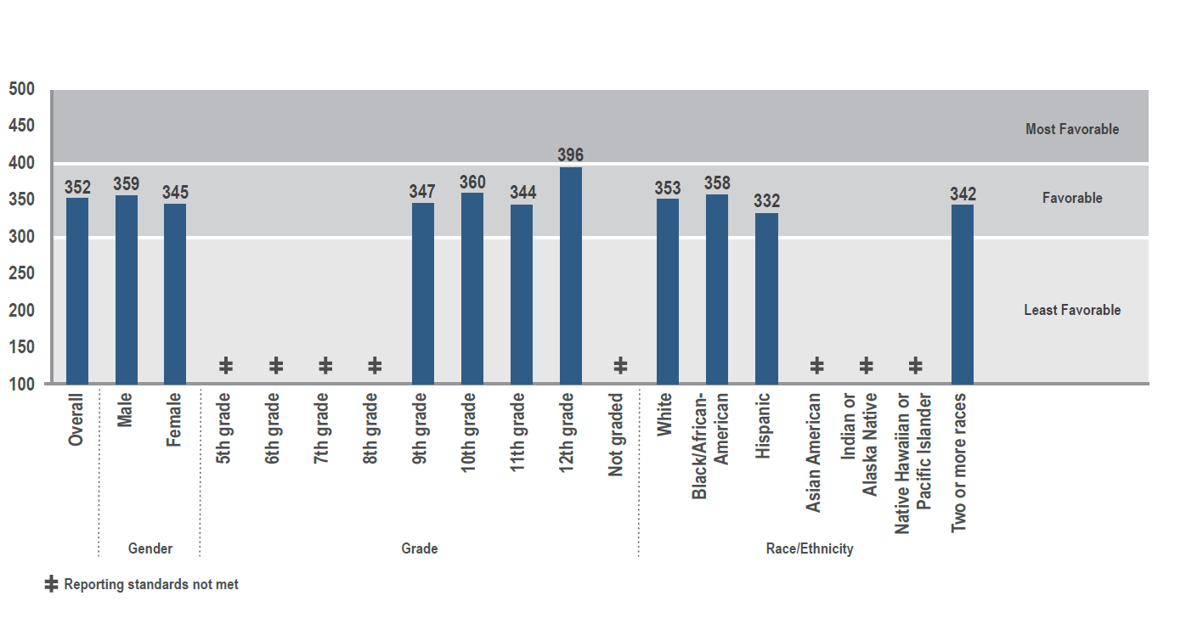
This example shows that the overall benchmarked student scale score for the Relationship topic area is 352 (on a scale of 100–500), which is within the Favorable performance level. You can compare this benchmarked score with those of the other Engagement topic areas among students. For example, if the benchmarked scale score for School Participation is 314 (within the Favorable level), and the CLC score is 297 (within the Least Favorable level), you may want to focus your school climate improvement efforts on issues around CLC. You can go through the same process for your instructional staff and noninstructional staff reports if you surveyed those respondent groups as well.
You can use the space below to record your observations from your benchmarked scale score reports. (The box will expand as you enter text.)
Enter results here.

- Within Engagement topic area(s) of interest, which benchmarked scale scores are more or less favorable within subgroups of students, instructional, or noninstructional staff?

Produce an EDSCLS report to find this information:
You can generate a benchmarked scale score report from the EDSCLS platform for each topic area by respondent characteristics in graphs that look like this example for the Relationships topic area (Figure 2):
Figure 2. Example of Student Benchmarked Scale Scores for Relationships, Overall and by Gender, Grade, and Race/Ethnicity
Note. This figure provides an example from a student report using the Relationships topic area. Similar graphs can be generated for each topic area and for instructional staff and noninstructional staff if you surveyed those groups. (Staff characteristics do not include grade.)
Using this figure, you can see the student benchmarked scale score for Relationships and in which performance level it falls for categories of each student characteristic (gender, grade, race/ethnicity). For example, in the figure shown, the Relationships score for male students is 359 and the score for female students is 345. Both are in the Favorable range, but male students’ perceptions of Relationships are more positive than are those for female students. Using these findings, you may want to focus your improvement efforts on girls’ perceptions around relationships in the school.
To learn more about using benchmarked scale scores by respondent characteristics, see the Data Interpretation Guide and Data Interpretation Topical Discussion Guides for the respective topic areas.
You can use the space below to record your observations from your benchmarked scale score report. (The box will expand as you enter text.)
Enter results here.

- Within Engagement topic area(s) of interest, how do students, instructional staff, noninstructional staff, or parents perceive specific items?

Produce an EDSCLS report to find this information:
You can run an item-level report using the EDSCLS platform that shows the percentage distribution and average (mean) of responses for items within topic areas. The platform produces graphs that look like this example for students for the Relationships topic area (chart 2).
Chart 2. Example of Student Item-Level Data for the Relationships Topic Area
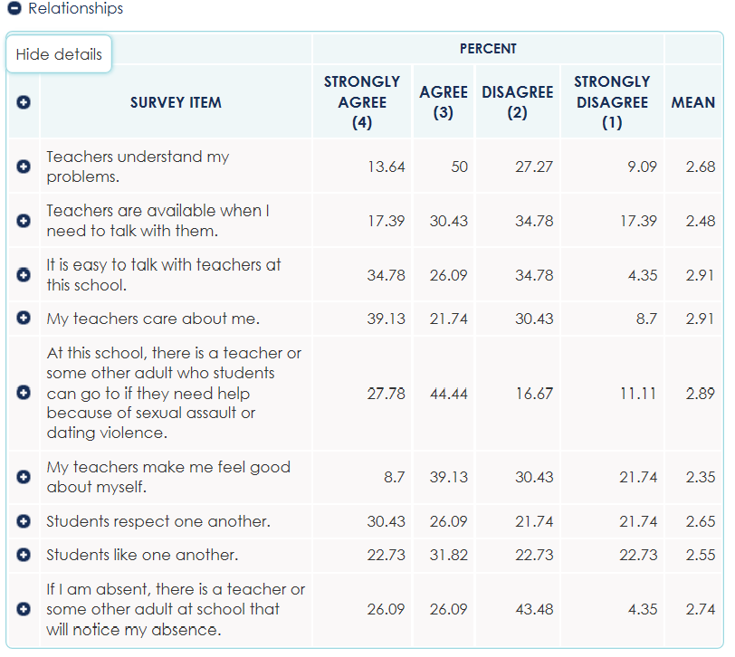Note. This chart provides an example from a student report using the Relationships topic area. Similar charts can be produced for items in other topic areas and for other respondent groups (i.e., instructional staff, noninstructional staff, and parents) if they were surveyed as well. Also, note that you cannot compare responses to a specific item across respondent groups unless the item is worded exactly the same.
This chart shows, for example, that more than half (about 64 percent) of students agree or strongly agree with the statement, “Teachers understand my problems,” but only about 48 percent agree or strongly agree with the statement, “Teachers are available when I need to talk to them.” Examining these item-level results suggests that, although most students perceive teachers as understanding, they do not think teachers are always available when they need them. A finding like this can help you decide where you may want to focus your improvement efforts, in this case working with teachers to increase their availability to students.
To learn more about various ways you can use item-level data, see the Data Interpretation Guide and Data Interpretation Topical Discussion Guides for the respective topic area(s).
You can use the space below to record your observations from your item-level report.
Enter results here.

Safety Domain
Now you can use the same three questions and instructions as for Engagement to dig into your reported results for the topic areas in the Safety domain (Emotional Safety, Physical Safety, Bullying/Cyberbullying, Substance Abuse). (Refer to the guidance in the Engagement section, as needed, to recall which reports to produce, as well as tips on analyzing your data in the Data Interpretation Guide and the Data Interpretation Topical Discussion Guides.)

- What are the benchmarked scale scores for topic areas within the Safety domain and in which “performance” levels do they fall, for students, instructional staff, and noninstructional staff?
Enter results here.

- Within Safety topic area(s) of interest, which benchmarked scale scores are more or less favorable within subgroups of students, instructional, or noninstructional staff?
Enter results here.

- Within Safety topic area(s) of interest, how do students, instructional staff, noninstructional staff, or parents perceive specific items?
Enter results here.

Environment Domain
Now you can use the same three questions and instructions as for Engagement to dig into your reported results for the topic areas in the Environment domain (Physical Environment, Instructional Environment, Physical Health, Mental Health, Discipline). (Refer to the guidance in the Engagement section, as needed, to recall which reports to produce, as well as tips on analyzing your data in the Data Interpretation Guide and the Data Interpretation Topical Discussion Guides.)

- What are the benchmarked scale scores for topic areas within the Environment domain and in which “performance” levels do they fall, for students, instructional staff, and noninstructional staff?
Enter results here.

- Within Environment topic area(s) of interest, which benchmarked scale scores are more or less favorable within subgroups of students, instructional, or noninstructional staff?
Enter results here.

- Within Environment topic area(s) of interest, how favorably do students, instructional staff, noninstructional staff, or parents perceive specific items?
Enter results here.

The EDSCLS platform produces graphs showing three “performance” levels into which the benchmarked scale scores may fall: Least Favorable (scale scores below 300): The most likely answer to each positively valenced question in the scale is disagree or strongly disagree; the most likely answer to each negatively valenced question in the scale is agree or strongly agree. Favorable (scale scores 300–400): The most likely answer to each positively valenced question in the scale is agree; the most likely answer to each negatively valenced question in the scale is disagree. Most Favorable (scale scores above 400–500): The most likely answer to each positively valenced question in the scale is strongly agree; the most likely answer to each negatively valenced question in the scale is strongly disagree. (See the Data Interpretation Guide for further information.)
Note that EDSCLS parent data are not scaled but can be analyzed at the item level.
EDSCLS does not produce a Physical Health scale score for students.

